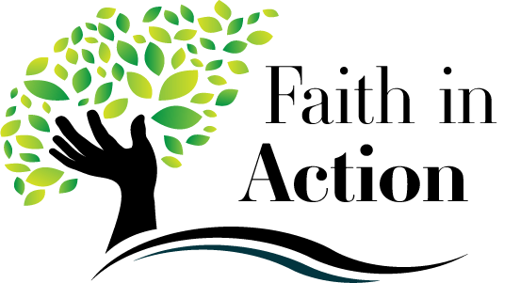
Activity #1 Name _______________________________
Bring this completed paper to class with you on Sunday Oct 15th or Wed Oct 18th

1. We all want the same things out of life: love, a sense of purpose and peace. Discuss with your parent the 5 personal goals you listed in Lesson 1 ‘Why Am I Here?’ Describe steps you can take to achieve them:

____________________________________________________________________________

____________________________________________________________________________

____________________________________________________________________________

____________________________________________________________________________

–––––––––––––––––––––––––––––––––––––––––––––––––––––––––––––––––––––––––––––––––––––

–––––––––––––––––––––––––––––––––––––––––––––––––––––––––––––––––––––––––––––––––––––

–––––––––––––––––––––––––––––––––––––––––––––––––––––––––––––––––––––––––––––––––––––

_____________________________________________________________________________________

2. Prayer can also help us to stay motivated and focused on our goals. Prayer is a powerful tool that can help us to achieve our goals. Read aloud with your family…

The Prayer of St. Francis

Lord, make me an instrument of your peace:
where there is hatred, let me sow love;
where there is injury, pardon;
where there is doubt, faith;
where there is despair, hope;
where there is darkness, light;
where there is sadness, joy.
O divine Master, grant that I may not so much seek
to be consoled as to console,
to be understood as to understand,
to be loved as to love.
For it is in giving that we receive,
it is in pardoning that we are pardoned,
and it is in dying that we are born to eternal life.
Amen.

a. What “words” in this prayer did you connect with? Explain why.

____________________________________________________________________
____________________________________________________________________
____________________________________________________________________
b. Describe an action you did this week that was inspired by this prayer? (3 or more sentences)

_______________________________________________________________________
_______________________________________________________________________
_______________________________________________________________________

_______________________________________________________________________

_______________________________________________________________________

_______________________________________________________________________

