Activity #11 – Grades 5-6
Bring this completed paper to class with you on Sunday, March 17 or Wednesday, March 20, 2024.

Name ________________________________
Carrying the Cross

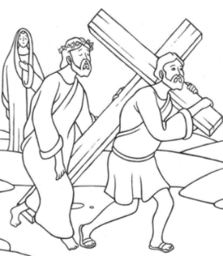
In the story of Jesus’ passion, Simon of Cyrene does something for Jesus. Read Matthew 27:32
What did Simon do?__________________________________________

During Lent, think of something you can do that will make somebody’s life easier, to help them carry their cross. You can help your parents or a friend. You can be good to someone who is not feeling well or has had a hard day. Ask your family for an idea of what you can do to help another person. We help each other to carry our cross, as Simon of Cyrene helped Jesus carry his cross.

What did you decide to do to help another person carry her/his cross? ______________________

______________________________________________________________________________

Whom did you talk to for help getting an idea? __________________________________________

You have received a small, simple stone engraved with a cross. The cross reminds us of Jesus’ love for us and the love we need to have for each other.

Use this cross and make a prayer place. You might put your cross on your dresser or desk so you can see it in the morning or when you do your homework. You can put the cross anywhere you look at often during the day. You might want to keep the cross in your pocket so you can touch it during the day and remember that God is always with you.

Ask someone in your family to help you decide on a good prayer place.

Where is your prayer place?_____________________________________________________

Why did you choose that as your prayer place? Why is that good for you? How will that help you?

_______________________________________________________________________________

______________________________________________________________________________

Whenever you look at or go to your prayer place, say a short prayer. Thank God for something. Or, you can ask God for help with something that is important to you.

