Activity #11 – Grades 1-4
Bring this completed paper to class with you on Sunday, March 17 or Wednesday, March 20, 2024.

Name ________________________________
Carrying the Cross

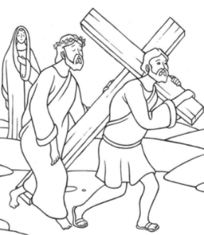
In the story of Jesus’ passion, Simon of Cyrene helps Jesus by carrying his cross. A cross can mean something that is difficult for us to do.

During Lent, think of something you can do that will make somebody’s life easier, to help them carry their cross. You can help your parents or a friend. You can be good to someone who is not feeling well or has had a hard day. Ask your family for an idea of what you can do to help another person. We help each other to carry our cross, as Simon of Cyrene helped Jesus carry his cross.

What did you decide to do to help another person carry her/his cross? ______________________

______________________________________________________________________________

Whom did you talk to for help getting an idea? __________________________________________

You have received a small, simple stone with an engraved cross. The cross reminds us of Jesus’ love for us and the love we need to have for each other.

Use this cross and make a prayer place. A prayer place is anywhere that is meaningful to you. You can put the cross on your dresser or desk, keep it somewhere you will look at often, or keep it in your pocket so you can touch it during the day. Ask someone in your family to help you decide on a good prayer place.

Where is your prayer place? ____________________________________________________
Whenever you look at or go to your prayer place, remember that God loves you very much, even more than you can imagine.

Draw a picture of yourself and your prayer place.

