Activity #11 Name ______________________________
Bring this completed paper to class with you on Sunday March 17 or Wed March 20

PRAYER DURING LENT
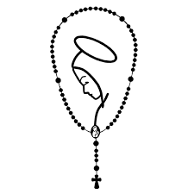
Part 1: Open your Chosen text book to page 246-247 to How to Pray the Rosary.

The rosary is a devotion centered on Jesus, through and with His mother.
It provides an opportunity to engage with the mysteries of Christ's life and
their relevance to our own spiritual journey.

1.Fill in the blanks:
A. The rosary is divided into four sets of mysteries: the _______________________Mysteries, the _________________________Mysteries, the _________________________Mysteries, and the ____________________________Mysteries (added by Pope John Paul II in 2002).
B. What is the first prayer said on the small chain? ____________________________________

C. How many Hail Mary’s are in a decade? _____________

D. The Decent of the Holy Spirit is meditated on which mystery? __________________________

E. What day or days are the Luminous Mysteries said? _____________________________

F. Which Mystery is NOT part of the Joyous Mystery? _______________________________________________
Annunciation, Baptism of Jesus, Visitation, Nativity

G. The Crowning with Thorns is meditated on which Mystery? ________________________________

2. Draw a line from the Mystery to the corresponding day it is meditated on:

Joyful Mystery Wednesday, Sunday

Luminous Mystery Monday, Saturday

Glorious Mystery Thursday

Sorrowful Mystery Tuesday, Friday

3. Take 5 minutes and say a decade of the rosary with a family member:

Who did you pray with? __________________________
Which Mystery did you meditate on ? ___________________________________
What day of the week? ___________________________

Part 2: Make a Rosary in a shell
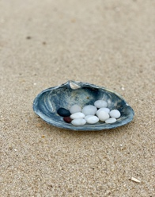

1. Go to the beach with a family member
(Cooper’s, Flying Point, North Sea, Meschutt etc.)

2. Collect the following:
1 large clam shell
10 small white pebbles (Hail Mary’s)
1 black pebble (Our Father)
1 brown pebble (Glory Be)

3. Take it home and wash everything

4. Leave it by your nightstand or on the coffee table

5. Use the pebbles to pray and meditate on the mysteries of the rosary when you feel the need!

Paste a photo of your rosary in a shell in the space below:

